Supplementary Information for Publication

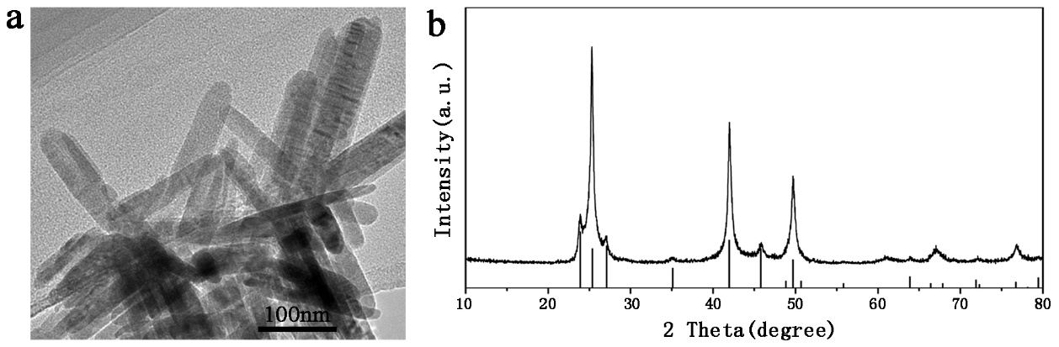
Fig. S1. Characterization of the synthesized CdSe nanorods. (a) TEM observation. (b) Powder XRD analysis.

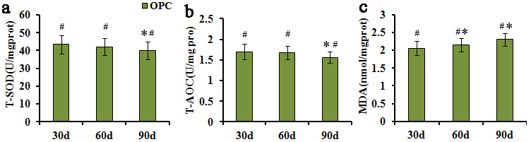
Fig. S2. The bar graph shows SOD and T-AOC activity (a, b) and MDA content (c) in rats’ lung tissue measured using microplate reader represented as mean ± SD of OPC treatment groups for 30, 60 and 90 days. (*p<0.05, as compared with normal control groups, #P<0.05, as compared with CdSe groups)

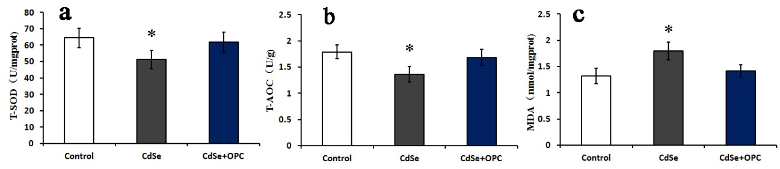
Fig. S3. The bar graph shows T-SOD (a), T-AOC activity (b) and MDA content (c) in A549 cells measured using microplate reader represented as mean ± SD. (*p<0.05, as compared with normal control group)

